H.T No
Regulations:
A15

Sreenidhi Institute of Science and Technology
(An Autonomous Institution)
Code No: 5F302 Date:10-Sept-2024 (FN)

B.Tech II-Year I- Semester External Examination, Sept - 2024 (Supplementary)
Mathematical Foundations of Computer Science (CSE & IT)

Time: 3 Hours Max.Marks:75

Note: a) No additional answer sheets will be provided.
b) All sub-parts of a question must be answered at one place only, otherwise it will not be valued.
c) Missing data can be assumed suitably.

Bloom's Cognitive Levels of Learning (BCLL)

Remember | L1 | Apply | L3 | Evaluate | L5
Understand | L2 | Analyze | L4 | Create | L6

Part - A Max.Marks:25
Answer all QUESTIONS

 |  | BCLL | CO(s) | Marks
1 | Define Tautology, Contradiction and Contingency. | L5 | CO1 | [2M]
2 | Determine whether the sequence 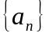 is a solution of the Recurrence Relation 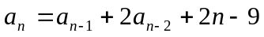, if 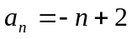. | L5 | CO2 | [2M]
3 | Define Least Upper Bound and Greatest Lower Bound. | L2 | CO3 | [2M]
4 | Define Cosets and Homomorphism of groups. | L1 | CO4 | [2M]
5 | Define a spanning tree. Give an example. | L1 | CO5 | [2M]
6 | Define Planar graph with an example. | L1 | CO6 | [3M]
7 | How Universal Generalization if different from Existential Generalization?. | L1 | CO1 | [3M]
8 | Define Compatability relation with an example. | L1 | CO3 | [3M]
9 | What is a Coset? Give an example. | L1 | CO6 | [3M]
10 | Define Semigroup with an example. | L1 | CO2 | [3M]
Part – B Max.Marks:50
ANSWER ANY FIVE QUESTIONS. EACH QUESTION CARRIES 10 MARKS.

 |  |  | BCLL | CO(s) | Marks
11. | a) | Show that P->Q = ~Q->~P through Truth Table construction. | L4 | CO1 | [5M]
 | b) | Obtain the Principal Conjunctive normal form of the formula given by (∼P→R)∧(Q↔P) | L4 | CO1 | [5M]
12. | a) | Verify the validity of the following argument: “All men are mortal. Socrates is a man. Therefore, Socrates is mortal.” | L3 | CO2 | [5M]
 | b) | Solve the Recurrence Relation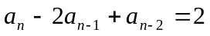. | L4 | CO2 | [5M]
13. | a) | Let X be any non empty set and P(X) is power set of A. Show that [P(X); ⊆] is a POSet. | L3 | CO3 | [5M]
 | b) | If R is an equivalence relation on a set A, then show that R₋₁ is also an equivalence relation | L2 | CO3 | [5M]
14. | a) | Explain about Monoid and Submonoid with giving an example each. | L2 | CO4 | [5M]
 | b) | State and prove Lagrange’s theorem. | L1 | CO4 | [5M]
15. | a) | Construct Spanning tree for the following graph using Breadth First Search and Depth First Search.  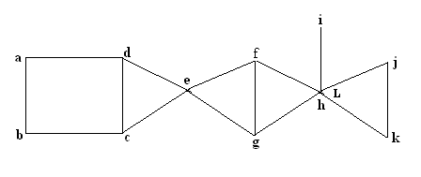 | L3 | CO5 | [5M]
 | b) | Write the constraints that must satisfy for two graphs are isomorphic. | L5 | CO5 | [5M]
16. | a) | Find the Euler path to the following graph.  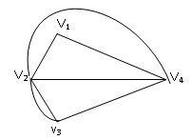 | L5 | CO6 | [5M]
 | b) | Find the Chromatic number for the following graph.  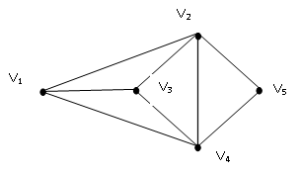 | L5 | CO6 | [5M]
17. | a) | Show that (∼P∧(∼Q∧R))∨(Q∧R)∨(P∧R) ⇔ R. | L2 | CO1 | [3M]
 | b) | Define Recurrence relation. Give an example. | L3 | CO2 | [4M]
 | c) | Show that [ D12 ; ] = [ {1, 2, 3,4, 6,12} ; ] is not a totally ordered set. | L3 | CO3 | [3M]
18. | a) | Explain about Algebraic system with an example. | L2 | CO4 | [4M]
 | b) | Discuss about Bipartite and Complete Bipartite Graphs. | L3 | CO5 | [3M]
 | c) | Draw the following.  i) A graph which is Both Hamiltonian and Eulerian.  ii) A graph which is Hamiltonian but not Eulerian. | L2 | CO6 | [3M]
-- 00 -- 00 –

